Question 4

Use Wireshark to capture DHCP Discover, Offer, Request, and Acknowledge messages and explain the process.

Approach

Now we are going to release the ip assigned by router and going to renew it to capture DHCP packets. Before this command. Start packet capture in wireshark and apply filter.

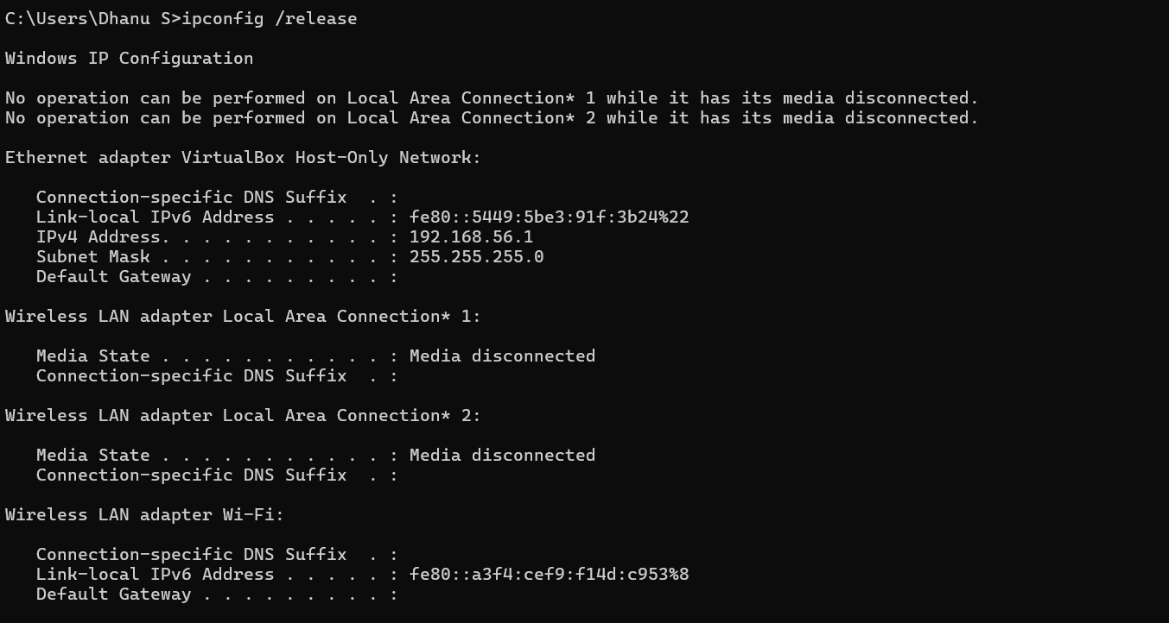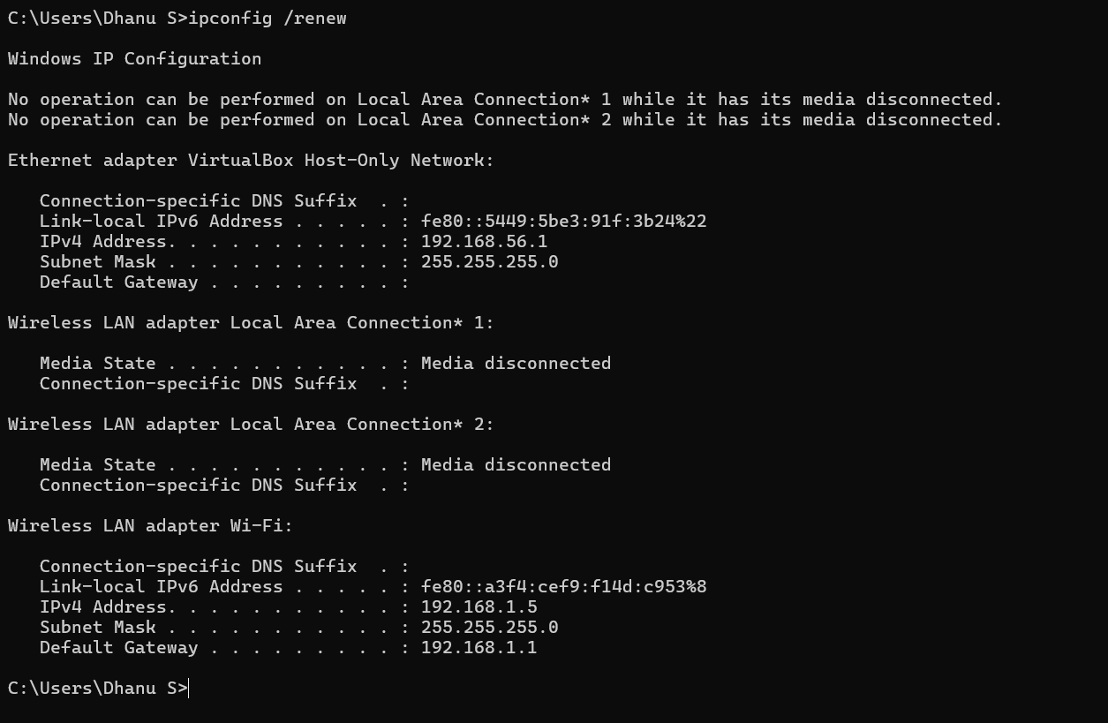

As you see we have four different packets. Discover, Offer, Request, Acknowledge



DHCP Discover Packet:

In this the local machine will discover the router by broad casting the packet which request for ip address.

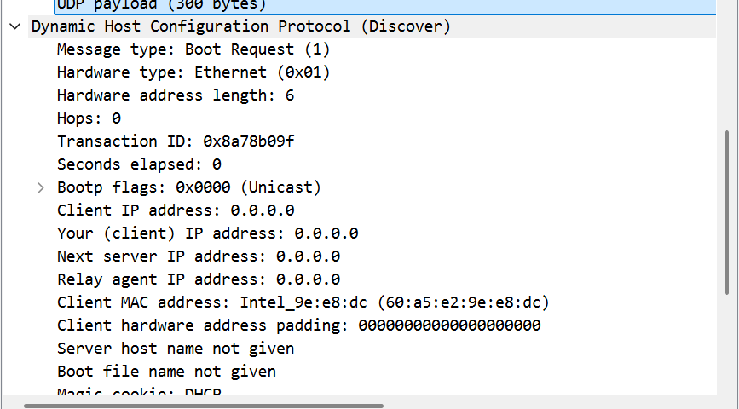

Once the route receives the discover packet, the router will offer the packet with available ip address. The packet will be broadcast to every system. This is called as DHCP Offer packet

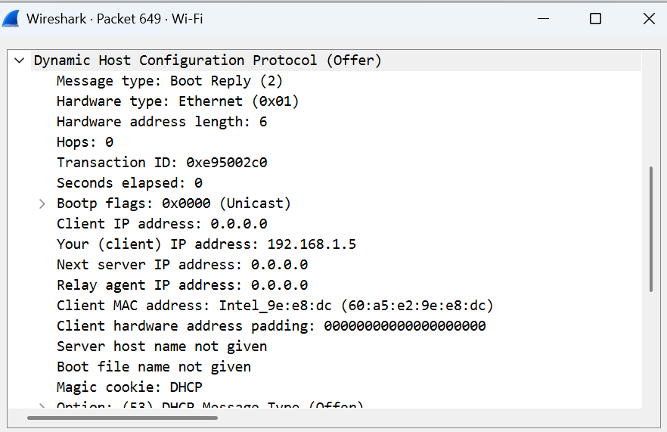

Once the offer is received the local machine will send a dhcp request packet requesting the available IP address.

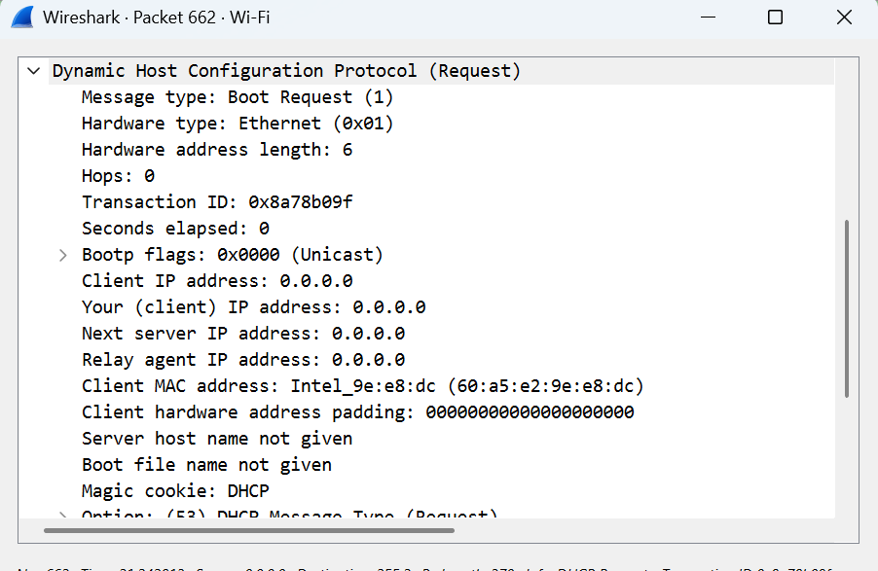

Once the offer packet received, The router will acknowledge the local machine with the assigned IP address.

